**TEST 6 (LESSONS 21 – 24)**

**Name: _______________________________________ Class: __________**

**1. Listen and tick (**✓**) the correct box. (_____/5 points)**

**Model:** □ Peter found a kitten.

☑ The bus was late again.

**1.** □ Peter saw a lot of bats.

□ Peter saw a lot of bats and cave paintings.

**2.** □ Peter told the teacher about his glasses before class.

□ Peter didn’t tell the teacher about his glasses before class.

**3.** □ Peter’s mum made the pancakes.

□ Peter’s sister made the pancakes.

**4.** □ Peter liked the music lesson best.

□ Peter liked the art lesson best.

**5.** □ Peter’s mum was ill.

□ Peter’s baby brother was ill.

**2. Read the text. Circle T (true) or F (false). (_____/5 points)**

Dad’s best friend is called Nick. Nick and Dad met at a karate club.

Nick was a bit plump but he was hard-working and patient and

he was the best of all. Dad was a bit lazy and he sometimes

missed his karate practice. At that time he loved drawing.

Last summer, Granny showed me his pictures.

In some of them there was a beautiful girl. That was my mum!

Now Dad is a dentist and Nick is … my PE teacher! ☺ Maria

**Model:** Maria’s dad and Nick did karate together. T / F

**1.** They met at school. T / F

**2.** At that time Nick wasn’t slim. T / F

**3.** Maria’s dad was hard-working. T / F

**4.** Maria saw pictures of her granny. T / F

**5.** Nick is a teacher at Maria’s school. T / F

**3. Fill in. (_____/5 points)**

~~awesome~~ dream herbal last toothache eye

**Model:** Come here! The view is awesome.

**1.** We often drink ___________ tea.

**2.** Jimmy is sad. He’s got ___________ .

**3.** Last summer, Olive’s ___________ came true.

**4.** They visited the Open-Air Museum ___________ month.

**5.** Help! I’ve got something in my ___________ .

**4. Choose and fill in. (_____/5 points)**

**Model:** ate – sent A dog ate my sandwich.

**1.** was – had Peter ___________ a birthday party last Sunday.

**2.** took – made We ___________ a lot of photos at the beach.

**3.** did – wrote Maria ___________ her homework in the evening.

**4.** stayed – tidied Jimmy ___________ his bedroom yesterday.

**5.** visited – arrived Last weekend, they ___________ at a small town.

**5. Look and write. Follow the model. (_____/10 points)**



**Model:**  give you

What did Megan give you? She gave me a ball.

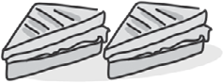**1.**  make

What ____________________ for breakfast?

__________________________________

**2.**  break 

What _____________________________?

__________________________________

**3.** see 

What _____________________________?

__________________________________

**4.**  write 

What _____________________________?

__________________________________



**5.** say 

What _____________________________?

__________________________________

**6. Look and write. Follow the model. (_____/10 points)**

**Model:** buy 



She didn’t buy any butter. She bought some cheese.

**1.**  go

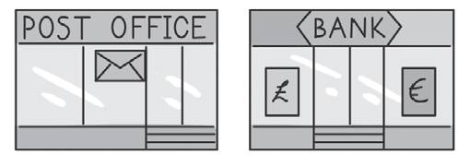

He _____________________ to the post office.

He _____________________ to the bank.

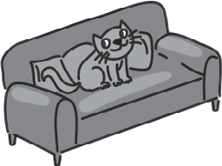**2.**  sleep

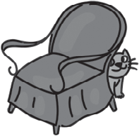

The cat _____________________ on the sofa.

The cat _____________________ behind the armchair.



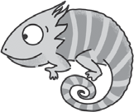

**3.** meet

They _____________________ Mr Rainbow.

They ____________ Mr Sporty.

_____________________

**4.** The show ⬩ start 



The show _____________________ at 7:00 pm.

It _____________________ at 7:30 pm.



**5.**  want 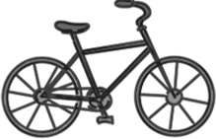

She _____________________ a bike for her birthday.

She _____________________ a dress.

**Total: _______/40 points**

**ANSWER KEY**

**1.** **Listen and tick (✓) the correct box.**

**1.** Peter saw a lot of bats.

**2.** Peter didn’t tell the teacher about his glasses before class.

**3.** Peter’s sister made the pancakes.

**4.** Peter liked the music lesson best.

**5.** Peter’s baby brother was ill.

**Transcript:**

**Model:**

**Peter:** Good morning, miss. I’m sorry, I’m late.

**Teacher:** Good morning, Peter. Was the bus late again?

**Peter:** No, miss, it wasn’t the bus. I found this kitten.

**Teacher:** Oh, it’s so cute. Where did you find it?

**1. Mum:** What did you see in the cave, Peter?

**Peter:** A lot of bats.

**Mum:** Did you see any cave paintings?

**Peter:** No, mum, there weren’t any paintings.

**2. Teacher:** Why aren’t you writing, Peter?

**Peter:** I’m sorry, miss, I broke my glasses yesterday and I can’t see well now.

**Teacher:** Why didn’t you tell me before class?

**Peter:** I’m sorry, miss, I forgot.

**3. Peter:** Mum, Dad, breakfast is ready!

**Mum:** What a surprise! Pancakes! And strawberry jam!

Did you and your sister make the pancakes together?

**Peter:** Yes, Mum, we did! In fact, Anniе made them but I broke the eggs!

**4. Mum:** Did you have a good time at the museum, Peter?

**Peter:** Yes, I did. The art lesson was boring, the science lesson was OK, but the music lesson was great! We listened to music and then we played some musical instruments.

It was so cool!

**5. Friend:** Hi, Peter! Why didn’t you come to the school trip? Were you ill?

**Peter:** No, I was OK but my baby brother was ill and I helped my mum.

**2. Read the text. Circle T (true) or F (false).**

**1.** F **2.** T **3.** F **4.** F 5**.** T

**3. Fill in.**

**1.** herbal **2.** toothache  **3.** dream **4.** last **5.** eye

**4. Choose and fill in.**

**1.** had **2.** took **3.** did **4.** tidied **5.** arrived

**5. Look and write. Follow the model.**

**1.** What did Miss Fairy make for breakfast?

She made two sandwiches.

**2.** What did the cat break?

It broke a/the vase.

**3.** What did Simon and Robin see?

They saw a dolphin.

**4.** What did Mr Sporty write?

He wrote a story.

**5.** What did Chan and Linda say?

They said ‘Bye-bye’.

**6. Look and write. Follow the model.**

**1.** He didn’t go to the post office.

He went to the bank.

**2.** The cat slept on the sofa.

It didn’t sleep behind the armchair.

**3.** They didn’t meet Mr Rainbow.

They met Mr Sporty.

**4.** The show didn’t start at 7:00 pm.

It started at 7:30 pm.

**5.** She wanted a bike for her birthday.

She didn’t want a dress.

**Оценяване**

Всеки верен отговор носи една точка.

|  |  |
| --- | --- |
| *Максимален брой точки* ***40*** | |
| *Точки* | *Оценка* |
| 0−8 | **2 Try again!** |
| 9−16 | **3 You need to revise!** |
| 17−24 | **4 Good!** |
| 25−32 | **5 Well done!** |
| 33−40 | **6 Excellent!** |