**HOP ON THE MERRY-GO-ROUND 7**

**Name:** ………………………………………………………….. **Class:** ………………

**1.** **Write the words.**

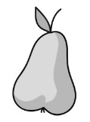  **1. p_ _ _**

 **2.** **c_ _ _ _ _**

 **3.** **l_ _ _ _ _ _**

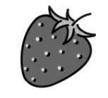 **4.** **s_ _ _ _ _ _ _ _ _**

 **5.** **m_ _ _ _**

 **6. c_ _ _ _ _ _**

 **7. c_ _ _ _ _ _ _**

**2.** **Write.**

 **1.** **It’s sunny.**

 **2.** …………………………..

 **3.** …………………………..

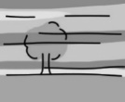 **4.** …………………………..

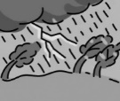 **5.** …………………………..

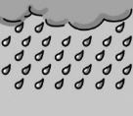 **6.** …………………………..

**3. Fill in.**

• storm • know • show • thunder • clouds • welcome • ~~quickly~~

**1.** Come here **quickly**!

**2.** …………………… to Bulgaria!

**3.** Let me ………………… you around our school.

**4.** Look at those ……………….! A ………………… is coming!

**5.** Megan is afraid of ………………… .

**6.** Do you ………………… her name?

**4. Write sentences.**

**1.** their ⬩ What ⬩ names ⬩ are ?

**What are their names?**

**2.** watching ⬩ Megan ⬩ rain ⬩ the ⬩ is .

………………………………………………………………………...

**3.** magic ⬩ got ⬩ Mr Sporty ⬩ has ⬩ keypad ⬩ a .

………………………………………………………………………...

**4.** What ⬩ your ⬩ are ⬩ vegetables ⬩ favourite ?

………………………………………………………………………...

**5.** the ⬩ What ⬩ today ⬩ like ⬩ is ⬩ weather ?

………………………………………………………………………...

**6.** Betty ⬩ read ⬩ can ⬩ is ⬩ only ⬩ five ⬩ but ⬩ she .

………………………………………………………………………...

**5. Write** *do* **or** *does****.***

**1.****Does** she like summer?

**2.** ………… he like cherries?

**3.** ………… you know his name?

**4.** ………… Linda have lunch at home?

**5.** ………… Miss Fairy collect mugs?

**6.** ………… Jimmy and Robin like ice cream?

**6. Fill in.**

**1. ~~he’s~~ he’s got his he’s**

This is Nick. **He’s** nine. ……………... my best friend. ……………... a hamster.

……………... name is Speedy.

**2. she’s her it’s she’s got**

Look at Betty. ……………... very happy today. ……………... a puppy.

……………... a present from ……………... mum and dad.

**3. they’re they’ve got their there**

These are my friends. ……………... names are John and Ann.

……………... very busy now. ……………... only twenty minutes to finish the project.

……………... are a lot of photos on the desk.

57

     

**HOP ON THE MERRY-GO-ROUND 7**

**Name:** ………………………………………………………….. **Class:** ………………

**1.** **Write the words.**

  **1. p_ _ _**

 **2.** **c_ _ _ _ _**

 **3.** **l_ _ _ _ _ _**

 **4.** **s_ _ _ _ _ _ _ _ _**

 **5.** **m_ _ _ _**

 **6. c_ _ _ _ _ _**

 **7. c_ _ _ _ _ _ _**

**2.** **Write.**

 **1.** **It’s sunny.**

 **2.** …………………………..

 **3.** …………………………..

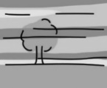 **4.** …………………………..

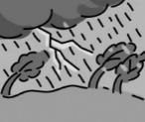 **5.** …………………………..

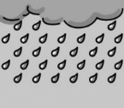 **6.** …………………………..

**3. Fill in. Be careful – there is an extra word!**

• storm • know • safe • show • guest • rainbow • thunder • clouds • welcome • ~~quickly~~ • calm

**1.** Come here **quickly**!

**2.** ………………… to Bulgaria!

**3.** Let me ………………… you around our school.

**4.** Look at those ……………….! A ………………… is coming!

**5.** Megan is afraid of …………………. .

**6.** Do you …………… her name?

**7.** ……………….. down! We’re ……………… in here.

**8.** Come in. Be my ……………… .

**4. Write sentences.**

**1.** their ⬩ What ⬩ names ⬩ are ?

**What are their names?**

**2.** watching ⬩ Megan ⬩ rain ⬩ the ⬩ is .

………………………………………………………………..

**3.** magic ⬩ got ⬩ Mr Sporty ⬩ has ⬩ keypad ⬩ a .

………………………………………………………………..

**4.** What ⬩ your ⬩ are ⬩ vegetables ⬩ favourite ?

………………………………………………………………..

**5.** the ⬩ What ⬩ today ⬩ like ⬩ is ⬩ weather ?

………………………………………………………………..

**6.** Betty ⬩ read ⬩ can ⬩ is ⬩ only ⬩ five ⬩ but ⬩ she .

………………………………………………………………..

**5.** **Write** *do* **or** *does****.***

**1. Does** she like summer?

**2.** ………… she like cherries?

**3.** ………… you know his name?

**4.** ………… Linda have lunch at home?

**5.** ………… Miss Fairy collect mugs?

**6.** ………… you like English?

**7.** ………… your friends like pizza?

**8.** ………… Jimmy and Robin like ice cream?

**9.** ………… your sister want to come with me?

**10.** ………… your mum work in a shop?

**6.** **Write sentences. Follow the models.**

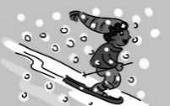 **1. Robin is skiing.**

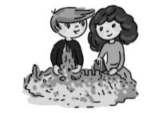 **2. Linda and Jimmy are making a sandcastle.**

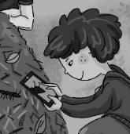 **3.** ………………………………………………………

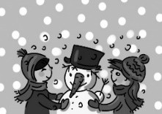 **4.** ………………………………………………………

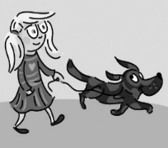 **5.** ………………………………………………………

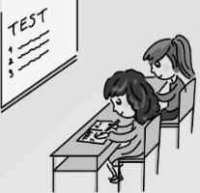 **6.** ………………………………………………………

**7. Fill in.**

**1. ~~he’s~~ he’s got his he’s**

This is Nick. **He’s** nine. ……………... my best friend. ……………... a hamster.

……………... name is Speedy.

**2. she’s her it’s she’s got**

Look at Betty. ……………... very happy today. ……………... a puppy.

……………... a present from ……………... mum and dad.

**3. they’re they’ve got their there**

These are my friends. ……………... names are John and Ann.

……………... very busy now. ……………... only twenty minutes to finish the project.

……………... are a lot of photos on the desk.

57

     